1. Create the following expressions as arrays or matrices,

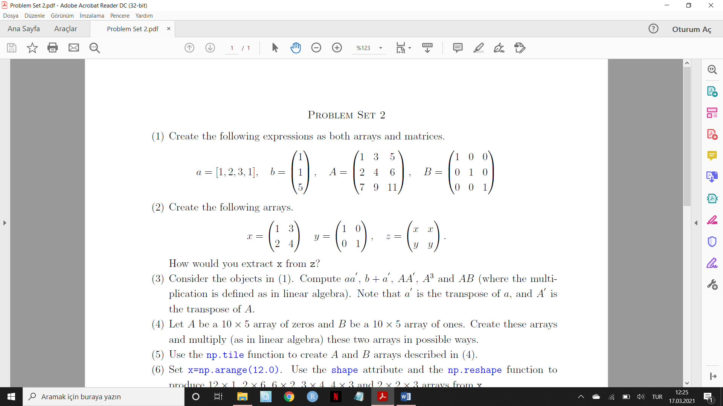

and compute

**first**=aa՛,

**second**=b + a՛,

**third**=AA՛,

**fourth**=A3 and

**fifth**=AB (where the multiplication is defined as in linear algebra). Note that a՛ is the transpose of a, and A՛ is the transpose of A. (variable names**: first**, **second**, **third**, **fourth**, **fifth**)

1. Let A be a (10x5) array of zeros and B be a (10x5) array of ones bu using the related functions. After creating these arrays multiply (as in linear algebra) them and give the name as **AB_multiplication.**

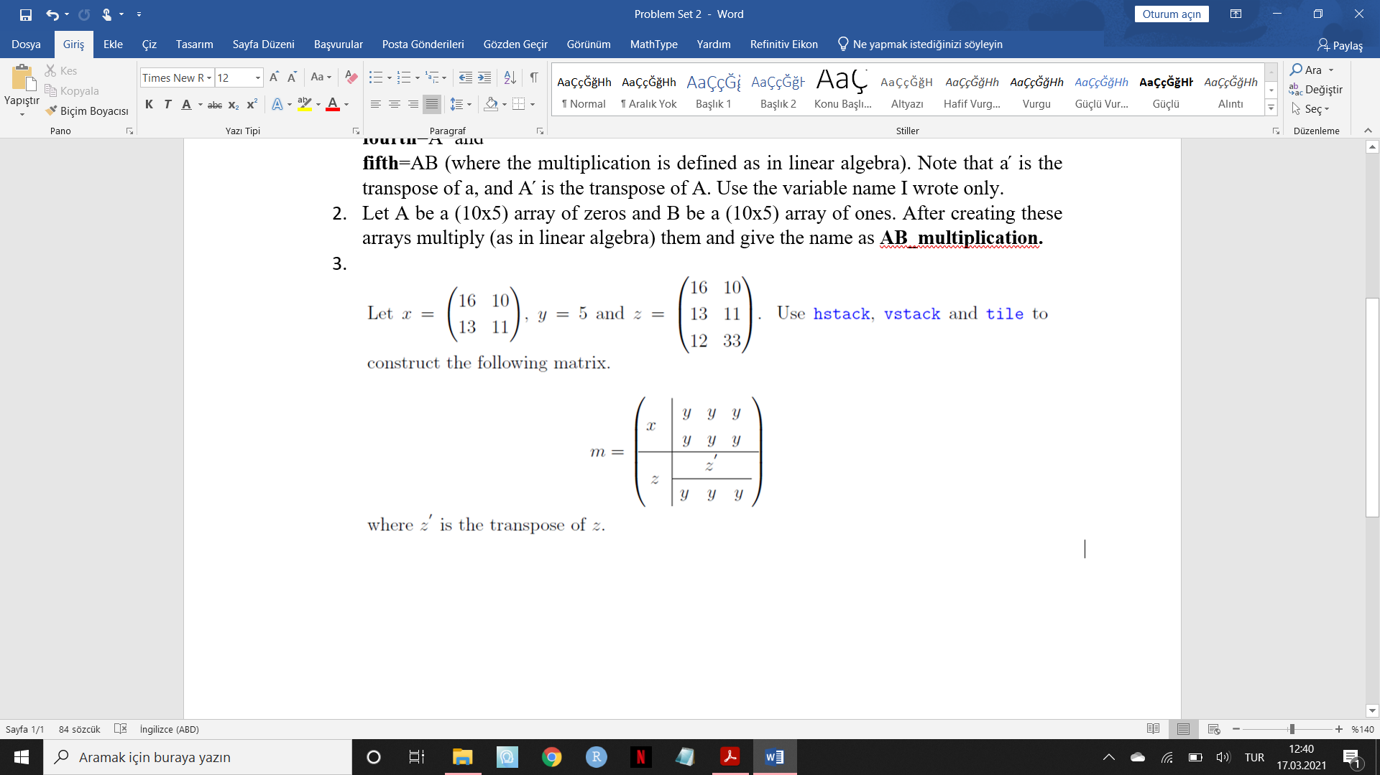

Variable name: **m**

1. Set x=np.arange(12.0). Reshape x to produce (2x2x3) and (2x3x2) arrays and find the multiplication under the **X_multiplication** name.
2. Use the np.diag function to construct a diagonal array from the diagonal elements of m given in (3), i.e., construct the Diag(m) array under the name of **M_diagonal**.

***P.S: Please use the variable names I wrote only.***